**Tutorial 6: Network Layer**

**Q1**

a) Explain TWO (2) functions of the router in the computer network. (201609 TAR UC, Main) (2 marks)

* It connect multiple IP networks
* It determine the best path to send packet
* It forward packet between computer network

b) Based on the diagram illustrated in Figure 1, answer the following questions. (201609 TAR UC, Main)

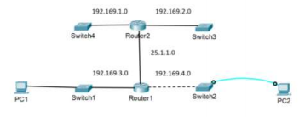

*Figure 1: ABC Network Company*

(i) How many networks shown in Figure 1? (1 mark)

* 5 networks (from router to any devices)

(ii) Locate the directly connected routes and remote routes for Router1. (5 marks)

|  | **Directly Connected Routes** | **Remote Routes** |
| --- | --- | --- |
| **Router 1** | 25.1.1.0 | 192.169.1.0 |
| 192.169.3.0 | 192.169.2.0 |
| 192.169.4.0 |  |

(iii) PC1 is trying to ping PC2. Predict whether the ping is successful or fail. Explain your reason. (5 marks)

* The ping request time out because PC2 is only connected to console cable which is not a networking cable (does not provide network access)
* The console interface does not have an IP address associated with it
* In this case, PC2 is only used to connect its terminal to the Switch2 console port to configure Switch2 through its terminal

(iv) Suggest your solution to rectify the situation in Question 1 b) (iii). (3 marks)

* PC2 will need to connect to an Ethernet cable such as straight-through cable as console cable is not intended to carry data from PC1 but instead create an interface with it only
* Moreover, Router 1 will need to configure static routing in order for PC1 and PC2 to communicate in remote networks.

c) Based on the diagram illustrated in Figure 1, answer the following questions. (201609 TAR UC, Main)

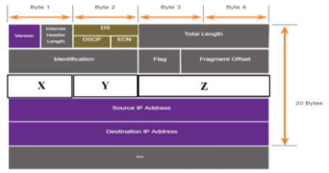

*Figure 2: IPv4 Packet Header Fields*

(i) Name X, Y, and Z. (3 marks)

* X - Time To Live
* Y - Protocol
* Z - Header Checksum

(ii) Name TWO (2) fields that are used to identify and validate the packet. (2 marks)

* Internet Header Length(IHL) & Total Length and Header Checksum

(iii) Discuss how X works. (4 marks)

* Time To Live (TTL) can be implemented by having a counter or timestamp attached in the data in order to make sure that data is discarded once the time limit is reached
* To illustrate, when TTL time limit reach to 0, the router will drop the packet

Time To Live (TTL) revolves around managing information packets in relation to Domain Name System (DNS) requests. When a packet is created and transmitted through the internet, there is a chance that it will pass, continuously, from router to router forever. To prevent this, each packet has a specific TTL or hop limit. It is also possible to examine the TTL of a data packet to obtain information on how it has moved through the internet over the course of its travels.

**Q2**. With reference to Figure 1, answer the following questions:

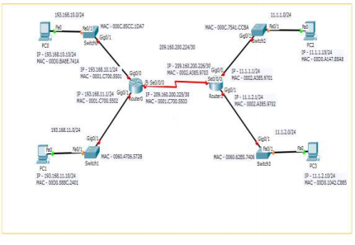*Figure 1: Main Campus network*

(i) In Figure 1, locate directly connected routes and remote routes for Router 1. (201609 TAR UC, Main) (5 marks)

|  | **Directly Connected Routes** | **Remote Route** |
| --- | --- | --- |
| **Router1** | 11.1.1.0/24 | 193.168.10.0/24 |
| 11.1.2.0/24 | 193.168.11.0/24 |
| 209.160.200.224/30 |  |

(ii) Using the table format given below, write the Layer 2 and Layer 3 addresses when PC0 ping to PC3. Add more rows to Table 1, if necessary. (201609 TAR UC, Main) (6 marks)

**: Layer 3 source and destination address will forever same**

| **Step** | **Layer 2**  **source**  **address** | **Layer 2**  **destination**  **address** | **Layer 3**  **source**  **address** | **Layer 3**  **destination**  **address** |
| --- | --- | --- | --- | --- |
| *PC0 to Switch0* | 00DO.BA8E.741A | 000C.85CC.1DA7 | 193.168.10.10/24 | 11.1.2.10/24 |
| *Switch0 to Router0* | 000C.85CC.1DA7 | 0001.C700.5501 | 193.168.10.10/24 | 11.1.2.10/24 |
| *Router0 to Router1* | 0001.C700.5503 | 0002.A385.9703 | 193.168.10.10/24 | 11.1.2.10/24 |
| *Router1 to Switch3* | 0002.A385.9702 | 0060.62B5.7406 | 193.168.10.10/24 | 11.1.2.10/24 |
| *Switch 3 to PC3* | 0060.62B5.7406 | 00D0.1042.C885 | 193.168.10.10/24 | 11.1.2.10/24 |

**Q3**. Based on the diagram shown in Figure 3, identify the remote network and next hop address for the respective network for Router 1 and Router 2. (201509 TAR UC, Main) (6 marks)

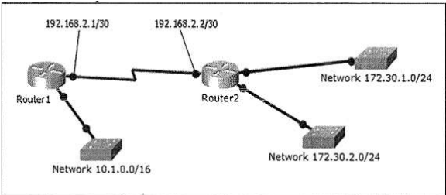

*Figure 3: Network Topology Diagram*

|  | **Remote Network Address** | **Next Hop Address** |
| --- | --- | --- |
| **Router1** | 172.30.1.0/24 | 192.168.2.2/30 |
| 172.30.2.0/24 | 192.168.2.2/30 |
| **Router2** | 10.1.0.0/16 | 192.168.2.1/30 |

**Q4**. With reference to Figure 2, answer the following questions:

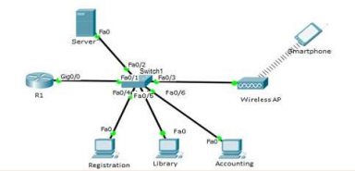

*Figure 2: A branch network*

(i) In Figure 2, identify the default gateway for Server and Smartphone. Indicate the device name and the interface clearly in your answer. (201605 TAR UC, resit) (4 marks)

* **Server** : default gateway (R1) & interface (Gig0/0)
* **Smartphone**: default gateway (R1) & interface (Gig0/0)

(ii) “When the Registration PC wants to send a message to Library PC, it is not required to configure default gateway in both PCs.”

Do you agree with the above statement? Justify your answer.

* Yes, I agree with this statement.
* This is because the Registration PC and Library PC are in the same local network.
* For local network delivery, the message is not required to be sent to the default gateway.
* Switch will directly forward the message based on the destination MAC address.

b) Figure 4 shows the network topology diagram of Sunrise Ltd.

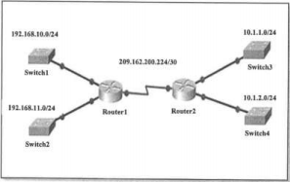

*Figure 4: Network Topology Diagram*

Based on the diagram shown in Figure 4, locate directly connected routes and remote routes for Router 1.

|  | **Directly Connected Routes** | **Remote Routes** |
| --- | --- | --- |
| **Router 1** | 192.168.10.0/24 | 10.1.1.0/24 |
| 192.168.11.0/24 | 10.1.2.0/24 |
| 209.162.200.224/30 |  |

IPv4 Packet

